**Running Collection Through Command Prompt:**

To run the request Through we need to install the node js

<https://nodejs.org/en/download>

Click on the above link and navigate to the download page and download the node js and install it.

Next open command prompt

node -v to see the version

Along with npm also install check the version by-

npm –version

Next install

npm install –g newman

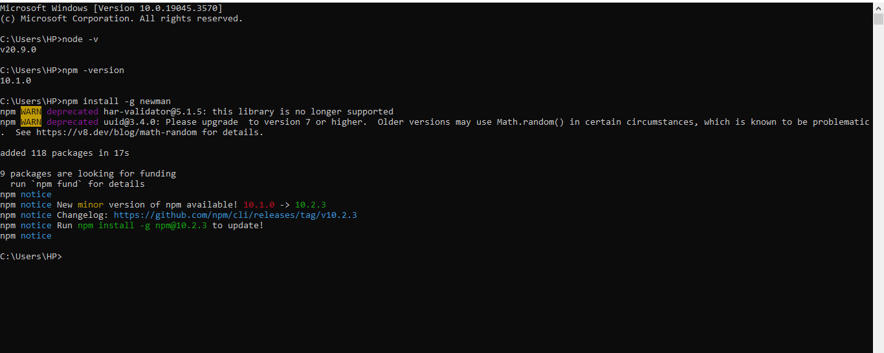

Now open postman select the collection we want to execute select the three dots and select export option then select folder and save the json file.

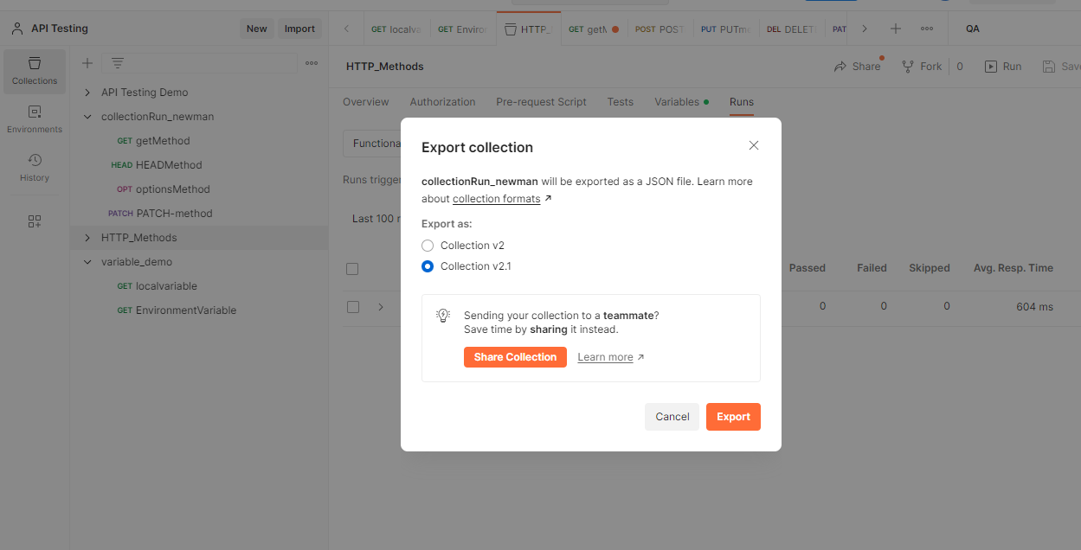

Next open the command prompt in the folder and give command

Newman run filename.json

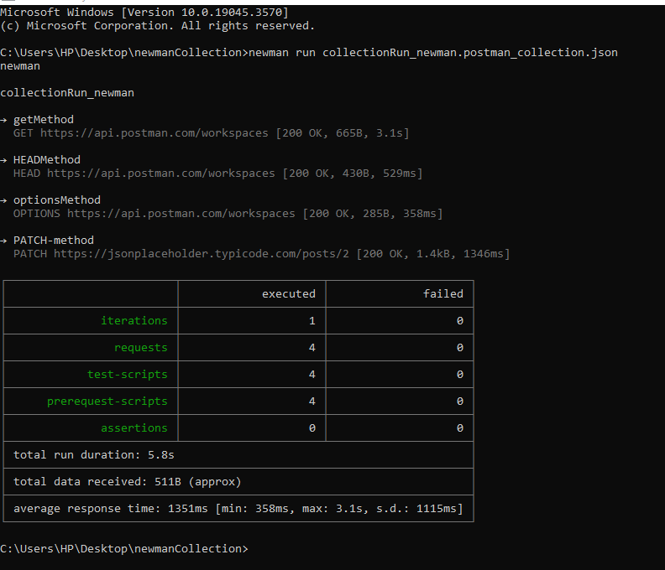

As we can see above the requests executed successfully.